2009 AP Computer Science A Free-Response Questions

- A statistician is studying sequences of numbers obtained by repeatedly tossing a six-sided number cube. On each side of the number cube is a single number in the range of 1 to 6, inclusive, and no number is repeated on the cube. The statistician is particularly interested in runs of numbers. A run occurs when two or more consecutive tosses of the cube produce the same value. For example, in the following sequence of cube tosses, there are runs starting at positions 1, 6, 12, and 14.

Index | 0 | 1 | 2 | 3 | 4 | 5 | 6 | 7 | 8 | 9 | 10 | 11 | 12 | 13 | 14 | 15 | 16 | 17
Result | 1 | 5 | 5 | 4 | 3 | 1 | 2 | 2 | 2 | 2 | 6 | 1 | 3 | 3 | 5 | 5 | 5 | 5

The number cube is represented by the following class.

public class NumberCube
{
/** @return an integer value between 1 and 6, inclusive
*/
public int toss()
{ /* implementation not shown */ }

// There may be instance variables, constructors, and methods that are not shown.
}

You will implement a method that collects the results of several tosses of a number cube and another method that calculates the longest run found in a sequence of tosses.

  - Write the method getCubeTosses that takes a number cube and a number of tosses as parameters.

Complete method getCubeTosses below.

/** Returns an array of the values obtained by tossing a number cube numTosses times.
* @param cube a NumberCube
* @param numTosses the number of tosses to be recorded
* Precondition: numTosses > 0
* @return an array of numTosses values
*/
public static int[] getCubeTosses(NumberCube cube, int numTosses)

  - Write the method getLongestRun that takes as its parameter an array of integer values representing a series of number cube tosses. The method returns the starting index in the array of a run of maximum size. A run is defined as the repeated occurrence of the same value in two or more consecutive positions in the array.

For example, the following array contains two runs of length 4, one starting at index 6 and another starting at index 14. The method may return either of those starting indexes.

If there are no runs of any value, the method returns -1.

Index | 0 | 1 | 2 | 3 | 4 | 5 | 6 | 7 | 8 | 9 | 10 | 11 | 12 | 13 | 14 | 15 | 16 | 17
Result | 1 | 5 | 5 | 4 | 3 | 1 | 2 | 2 | 2 | 2 | 6 | 1 | 3 | 3 | 5 | 5 | 5 | 5

Complete method getLongestRun below.

/** Returns the starting index of a longest run of two or more consecutive repeated values
* in the array values.
* @param values an array of integer values representing a series of number cube tosses
* Precondition: values.length > 0
* @return the starting index of a run of maximum size; -1 if there is no run
*/
public static int getLongestRun(int[] values)

- This question involves reasoning about the code from the GridWorld case study. A copy of the code is provided as part of this exam.

A StockpileCritter is a Critter that uses other actors as a source of energy. Each actor represents one unit of energy. The StockpileCritter behaves like a Critter except in the way that it interacts with other actors. Each time the StockpileCritter acts, it gathers all neighboring actors by removing them from the grid and keeps track of them in a stockpile. The StockpileCritter then attempts to reduce its stockpile by one unit of energy. If the stockpile is empty, the StockpileCritter runs out of energy and removes itself from the grid.

Consider the following scenario.

INITIAL WORLD AFTER ONE ACT AFTER TWO ACTS
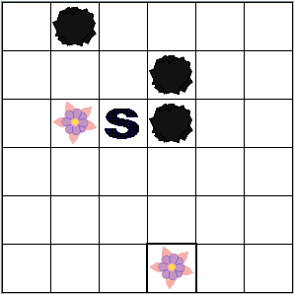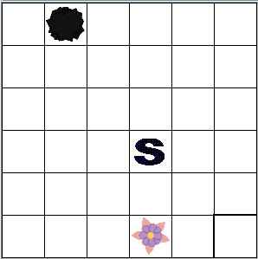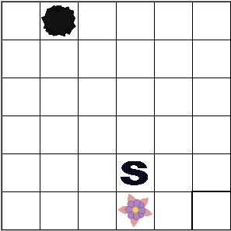
StockpileCritter Gathered 3 actors, No actors gathered,
is in location (2, 2), used 1 energy unit, used 1 energy unit,
stockpile is empty 2 remaining in stockpile, 1 remaining in stockpile,
moved to location (3, 3) moved to location (4, 3)

AFTER THREE ACTS AFTER FOUR ACTS AFTER FIVE ACTS
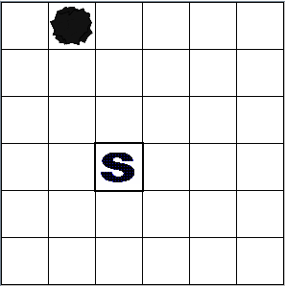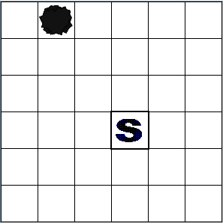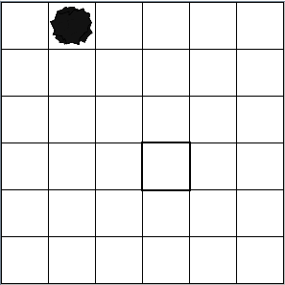
Gathered 1 actor, No actors gathered, Stockpile empty,
used 1 energy unit, used 1 energy unit, removed self from grid
1 remaining in stockpile, 0 remaining in stockpile,
moved to location (3, 2) moved to location (3, 3)

Write the complete StockpileCritter class, including all instance variables and required methods. Do NOT override the act method. Remember that your design must not violate the postconditions of the methods of the Critter class and that updating an object’s instance variable changes the state of that object.

- An electric car that runs on batteries must be periodically recharged for a certain number of hours. The battery technology in the car requires that the charge time not be interrupted.

The cost for charging is based on the hour(s) during which the charging occurs. A rate table lists the 24 one-hour periods, numbered from 0 to 23, and the corresponding hourly cost for each period. The same rate table is used for each day. Each hourly cost is a positive integer. A sample table is given below.

Hour | Cost |  | Hour | Cost |  | Hour | Cost
0 | 50 |  | 8 | 150 |  | 16 | 200
1 | 60 |  | 9 | 150 |  | 17 | 200
2 | 160 |  | 10 | 150 |  | 18 | 180
3 | 60 |  | 11 | 200 |  | 19 | 180
4 | 80 |  | 12 | 40 |  | 20 | 140
5 | 100 |  | 13 | 240 |  | 21 | 100
6 | 100 |  | 14 | 220 |  | 22 | 80
7 | 120 |  | 15 | 220 |  | 23 | 60

The class BatteryCharger below uses a rate table to determine the most economic time to charge the battery. You will write two of the methods for the BatteryCharger class.

public class BatteryCharger
{
/** rateTable has 24 entries representing the charging costs for hours 0 through 23. */
private int[] rateTable;

/** Determines the total cost to charge the battery starting at the beginning of startHour.
* @param startHour the hour at which the charge period begins
* Precondition: 0 ≤ startHour ≤ 23
* @param chargeTime the number of hours the battery needs to be charged
* Precondition: chargeTime > 0
* @return the total cost to charge the battery
*/
private int getChargingCost(int startHour, int chargeTime)
{ /* to be implemented in part (a) */ }

/** Determines start time to charge the battery at the lowest cost for the given charge time.
* @param chargeTime the number of hours the battery needs to be charged
* Precondition: chargeTime > 0
* @return an optimal start time, with 0 ≤ returned value ≤ 23
*/
public int getChargeStartTime(int chargeTime)
{ /* to be implemented in part (b) */ }

// There may be instance variables, constructors, and methods that are not shown.
}

  - Write the BatteryCharger method getChargingCost that returns the total cost to charge a battery given the hour at which the charging process will start and the number of hours the battery needs to be charged.

For example, using the rate table given at the beginning of the question, the following table shows resulting costs of several possible charges.

Start Hour of  Charge | Hours of Charge  Time | Last Hour of  Charge | Total Cost
12 | 1 | 12 | 40
0 | 2 | 1 | 110
22 | 7 | 4 (the next day) | 550
22 | 30 | 3 (two days later) | 3,710

Note that a charge period consists of consecutive hours that may extend over more than one day.

Complete method getChargingCost below.

/** Determines the total cost to charge the battery starting at the beginning of startHour.
* @param startHour the hour at which the charge period begins
* Precondition: 0 ≤ startHour ≤ 23
* @param chargeTime the number of hours the battery needs to be charged
* Precondition: chargeTime > 0
* @return the total cost to charge the battery
*/
private int getChargingCost(int startHour, int chargeTime)

  - Write the BatteryCharger method getChargeStartTime that returns the start time that will allow the battery to be charged at minimal cost. If there is more than one possible start time that produces the minimal cost, any of those start times can be returned.

For example, using the rate table given at the beginning of the question, the following table shows the resulting minimal costs and optimal starting hour of several possible charges.

Hours of Charge  Time | Minimum  Cost | Start Hour of  Charge | Last Hour of  Charge
1 | 40 | 12 | 12
2 | 110 | 0  or  23 | 1  0 (the next day)
7 | 550 | 22 | 4 (the next day)
30 | 3,710 | 22 | 3 (two days later)

Assume that getChargingCost works as specified, regardless of what you wrote in part (a).

Complete method getChargeStartTime below.

/** Determines start time to charge the battery at the lowest cost for the given charge time.
* @param chargeTime the number of hours the battery needs to be charged
* Precondition: chargeTime > 0
* @return an optimal start time, with 0 ≤ returned value ≤ 23
*/
public int getChargeStartTime(int chargeTime)

- A game uses square tiles that have numbers on their sides. Each tile is labeled with a number on each of its four sides and may be rotated clockwise, as illustrated below.

INITIAL AFTER 1 AFTER 2 AFTER 3 AFTER 4
ROTATION ROTATIONS ROTATIONS ROTATIONS
 | 4 |  |  |  | 4 |  |  |  | 7 |  |  |  | 3 |  |  |  | 4
4 |  | 3 |  | 7 |  | 4 |  | 3 |  | 4 |  | 4 |  | 7 |  | 4 |  | 3
 | 7 |  |  |  | 3 |  |  |  | 4 |  |  |  | 4 |  |  |  | 7

The tiles are represented by the NumberTile class, as given below.

public class NumberTile
{
/** Rotates the tile 90 degrees clockwise
*/
public void rotate()
{ /* implementation not shown */ }

/** @return value at left edge of tile
*/
public int getLeft()
{ /* implementation not shown */ }

/** @return value at right edge of tile
*/
public int getRight()
{ /* implementation not shown */ }

// There may be instance variables, constructors, and methods that are not shown.
}

Tiles are placed on a game board so that the adjoining sides of adjacent tiles have the same number. The following figure illustrates an arrangement of tiles and shows a new tile that is to be placed on the game board.

GAME BOARD NEW TILE
 |  | 4 |  |  |  | 6 |  |  |  | 1 |  |  |  | 3 |  |  |  | 5 |  |  |  |  |  | 4
 | 4 |  | 3 |  | 3 |  | 4 |  | 4 |  | 2 |  | 2 |  | 2 |  | 2 |  | 9 |  |  |  | 2 |  | 2
 |  | 7 |  |  |  | 3 |  |  |  | 3 |  |  |  | 5 |  |  |  | 2 |  |  |  |  |  | 9
Position |  | 0 |  |  |  | 1 |  |  |  | 2 |  |  |  | 3 |  |  |  | 4

In its original orientation, the new tile can be inserted between the tiles at positions 2 and 3 or between the tiles at position 3 and 4. If the new tile is rotated once, it can be inserted before the tile at position 0 (the first tile) or after the tile at position 4 (the last tile). Assume that the new tile, in its original orientation, is inserted between the tiles at positions 2 and 3. As a result of the insertion, the tiles at positions 3 and 4 are moved one location to the right, and the new tile is inserted at position 3, as shown below.

GAME BOARD AFTER INSERTING TILE
 |  | 4 |  |  |  | 6 |  |  |  | 1 |  |  |  | 4 |  |  |  | 3 |  |  |  | 5
 | 4 |  | 3 |  | 3 |  | 4 |  | 4 |  | 2 |  | 2 |  | 2 |  | 2 |  | 2 |  | 2 |  | 9
 |  | 7 |  |  |  | 3 |  |  |  | 3 |  |  |  | 9 |  |  |  | 5 |  |  |  | 2
Position |  | 0 |  |  |  | 1 |  |  |  | 2 |  |  |  | 3 |  |  |  | 4 |  |  |  | 5

A partial definition of the TileGame class is given below.

public class TileGame
{
/** represents the game board; guaranteed never to be null */
private ArrayList<NumberTile> board;

public TileGame()
{ board = new ArrayList<NumberTile>(); }

/** Determines where to insert tile, in its current orientation, into game board
* @param tile the tile to be placed on the game board
* @return the position of tile where tile is to be inserted:
* 0 if the board is empty;
* -1 if tile does not fit in front, at end, or between any existing tiles;
* otherwise, 0 ≤ position returned ≤ board.size()
*/
private int getIndexForFit(NumberTile tile)
{ /* to be implemented in part (a) */ }

/** Places tile on the game board if it fits (checking all possible tile orientations if necessary).
* If there are no tiles on the game board, the tile is placed at position 0.
* The tile should be placed at most 1 time.
* Precondition: board is not null
* @param tile the tile to be placed on the game board
* @return true if tile is placed successfully; false otherwise
* Postcondition: the orientations of the other tiles on the board are not changed
* Postcondition: the order of the other tiles on the board relative to each other is not changed
*/
public boolean insertTile(NumberTile tile)
{ /* to be implemented in part (b) */ }

// There may be instance variables, constructors, and methods that are not shown.
}

  - Write the TileGame method getIndexForFit that determines where a given tile, in its current orientation, fits on the game board. A tile can be inserted at either end of a game board or between two existing tiles if the side(s) of the new tile match the adjacent side(s) of the tile(s) currently on the game board. If there are not tiles on the game board, the position for the insert is 0. The method returns the position that the new tile will occupy on the game board after it has been inserted. If there are multiple possible positions for the tile, the method will return any one of them. If the given tile does not fit anywhere on the game board, the method returns -1.

For example, the following diagram shows a game board and two potential tiles to be placed. The call getIndexForFit(tile1) can return either 3 or 4 because tile1 can be inserted between the tiles at position 2 and 3, or between the tiles at positions 3 and 4. The call getIndexForFit(tile2) returns -1 because tile2, in its current orientation, does not fit anywhere on the game board.

GAME BOARD tile1 tile2
 |  | 4 |  |  |  | 6 |  |  |  | 1 |  |  |  | 3 |  |  |  | 5 |  |  |  |  | 4 |  |  |  | 4
 | 4 |  | 3 |  | 3 |  | 4 |  | 4 |  | 2 |  | 2 |  | 2 |  | 2 |  | 9 |  |  | 2 |  | 2 |  | 8 |  | 2
 |  | 7 |  |  |  | 3 |  |  |  | 3 |  |  |  | 5 |  |  |  | 2 |  |  |  |  | 9 |  |  |  | 9
Position |  | 0 |  |  |  | 1 |  |  |  | 2 |  |  |  | 3 |  |  |  | 4

Complete method getIndexForFit below.

/** Determines where to insert tile, in its current orientation, into game board
* @param tile the tile to be placed on the game board
* @return the position of tile where tile is to be inserted:
* 0 if the board is empty;
* -1 if tile does not fit in front, at end, or between any existing tiles;
* otherwise, 0 ≤ position returned ≤ board.size()
*/
private int getIndexForFit(NumberTile tile)

  - Write the TileGame method insertTile that attempts to insert the given tile on the game board. The method returns true if the tile is inserted successfully and false only if the tile cannot be placed on the board in any orientation.

Assume that getIndexForFit works as specified, regardless of what you wrote in part (a).

Complete method insertTile below.

/** Places tile on the game board if it fits (checking all possible tile orientations if necessary).
* If there are no tiles on the game board, the tile is placed at position 0.
* The tile should be placed at most 1 time.
* Precondition: board is not null
* @param tile the tile to be placed on the game board
* @return true if tile is placed successfully; false otherwise
* Postcondition: the orientations of the other tiles on the board are not changed
* Postcondition: the order of the other tiles on the board relative to each other is not changed
*/
public boolean insertTile(NumberTile tile)

